HogDog Website – Design Spec (v1)
Oct 8, 2026 · @AMY

Purpose and goals
The site is a simple, mobile-friendly front door: it explains who HogDog is, shows the property, introduces the instructors for each sport, and sends every booking or question to the right place. It does not run bookings, payments, memberships or user accounts itself.
Guiding principle: the website informs, Acuity books. Anything that needs a calendar slot, a deposit or an approval lives in Acuity (or in a monitored inbox), never in custom website code.
The site must:
- Explain who we are and what we offer, in plain language
- Showcase the property (arena, pool, tiny house, RV and camping areas, farm)
- Give each discipline its own page with its instructors and their direct contact information
- Route requests correctly: Acuity for arena and pool rentals, camping@hogdogproductions.net for RV and camping, info@hogdogproductions.net for everything else
- Show a public calendar of events
- Provide private, link-only pages where trial information can be posted

Audiences
Five groups use the site; each should reach what they need in two clicks from the home page.
Audience | What they need | Where they end up
Prospective students and dog owners | What we teach, who teaches it, how to contact the instructor | Sport page, instructor contact
Arena and pool renters | Rules, availability, how to book | Scheduling page, then Acuity
RV, camping and tiny house guests | What is offered, how to ask | Tiny house page, camping@ email
Trial exhibitors and attendees | Dates, location, trial details | Calendar, then private trial page by link
Everyone else (sponsors, press, general questions) | Who we are, how to reach us | About page, info@ email

Site map
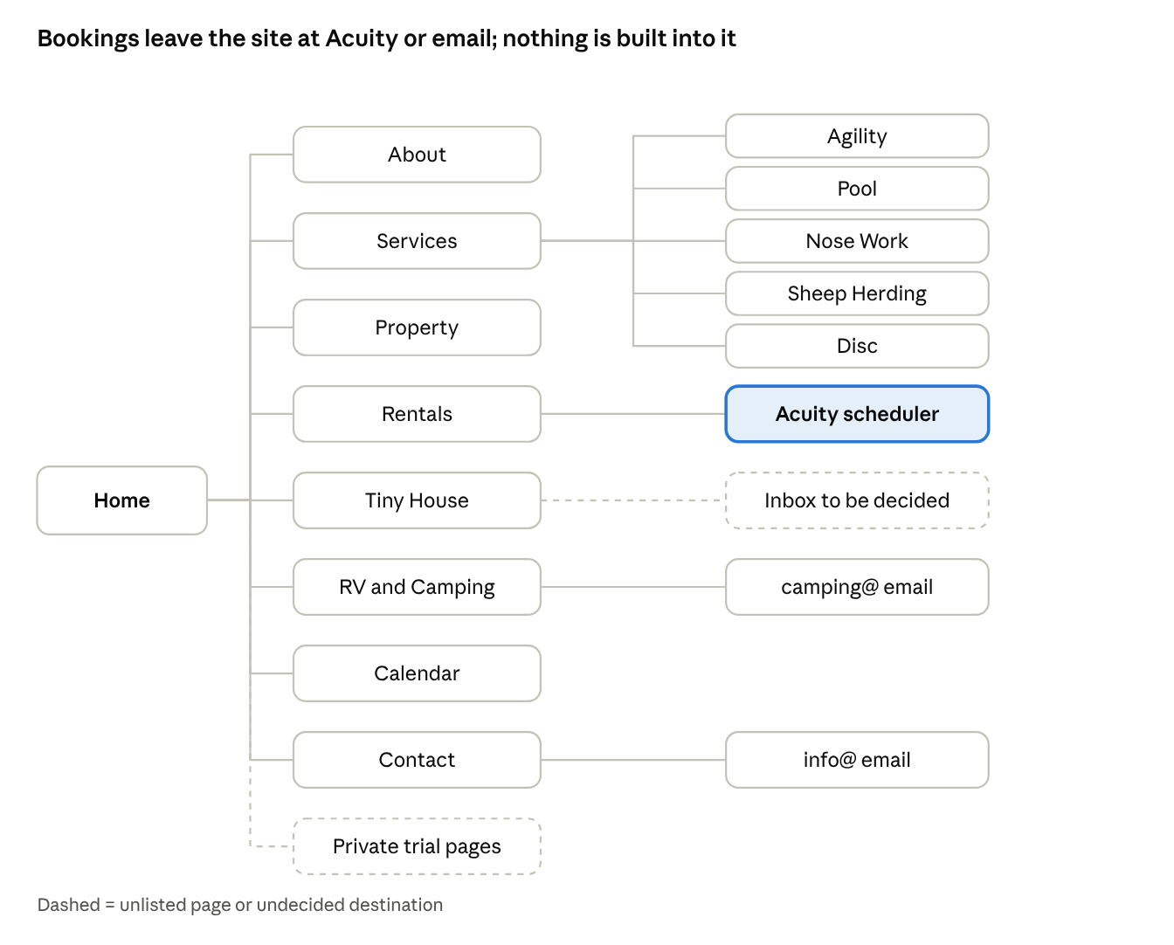
site map · 9 pages, 3 booking destinations
Services opens the five sport pages, each listing its instructors; the boxes on the right show where each request goes.

Page requirements
Every page carries the same header navigation, a footer with the info@ address, and a clear next step.
Page | Must contain | Primary action
Home | One-line description of HogDog, hero photo of the property, short cards for each service, link to calendar | Explore services or rent time
About | Who we are, the farm story, what makes the facility different | Contact us (info@)
Services | Overview of everything offered: agility, pool, nose work, sheep herding, disc, rentals, tiny house, RV and camping | Jump to each service page
Property | Photo gallery and short descriptions of the arena, pool, tiny house, RV and camping areas, and farm | View rentals
Agility | Program overview, then one card per instructor with photo, short bio and direct contact information | Contact an instructor
Pool | Overview, then one card per pool instructor with direct contact information | Contact an instructor
Nose Work | Overview, then instructor cards with direct contact information | Contact an instructor
Sheep Herding | Overview, then instructor cards with direct contact information | Contact an instructor
Disc | Overview, then instructor cards with direct contact information | Contact an instructor
Rentals (arena and pool) | Rules, rates, what is included, who may rent, how scheduling works, embedded or linked Acuity scheduler | Book in Acuity
Tiny House | Photos, description, amenities, house rules, how to inquire | Email request to the correct inbox (see open questions)
RV and Camping | Hookups, rules, how to request a stay | Email camping@hogdogproductions.net
Calendar | Public events calendar (see Calendar section) | Open an event for details
Contact | info@hogdogproductions.net and a short explanation of which address to use for what | Send email
Instructor cards use one consistent layout on every sport page: photo, name, role or specialty, two to three sentence bio, and direct contact information. Content comes from the instructors themselves.

Booking and contact routing
Three destinations cover every request, so visitors never have to guess.
Request type | Goes to | How it appears on the site
Arena rental | Acuity scheduling | Button or embedded scheduler on the Rentals page
Pool rental | Acuity scheduling | Same page; pool access rules shown above the scheduler
RV and camping reservations | camping@hogdogproductions.net | Email button on the RV and Camping page
Tiny house inquiries | To be decided (see open questions) | Description page with a single request button
Instructor questions and lessons | The instructor's direct contact | Instructor card on each sport page
Everything else | info@hogdogproductions.net | Contact page and footer on every page
Rules for the design:
- Use email buttons (a mail link that opens a pre-addressed message with a suggested subject line), not a contact form, so no new system has to be monitored
- Show only the email addresses above for general contact; instructors' direct contact details appear only on their own cards
- Pool rental copy must make any approval or waiver requirement clear before the visitor reaches the scheduler

Calendar
A public events calendar, kept separate from rental bookings so private reservations can never appear on it.
- Source: a dedicated events-only Google Calendar in the existing Google Workspace account, embedded on the site. Admins add or edit events there; the site updates by itself.
- Views: month grid on desktop; a month-by-month scrolling list on phones. Visitors can page through the whole year.
- Color coding by event type (for example trials, classes and seminars, other events), with a small legend.
- Event details: clicking an event shows title, date, time, a short description, and a link when more information exists (for example the trial page).
- Never shown: arena, pool, RV, camping or tiny house bookings. Acuity blocked times also stay off it.
- Visibility: the earlier draft said only trials, fast cat and disc should be public. Confirm whether that still holds, since it decides which event types go on this calendar.

Private trial pages
Each trial gets its own subpage that is reachable only by direct link. A link-only page is hidden, not secured: anyone who receives the link can open it and share it.
Requirements:
- One subpage per trial, created by an admin without developer help
- Not linked from the menu, footer, calendar or any public page
- Excluded from search engines (no-index) and from the site's sitemap
- Typical content: schedule, running order or classes, directions and parking, ring or area maps, rules and announcements, and PDFs or links to results
- Links shared by email or social media; the calendar entry may point to the page only when the trial is meant for public viewing
Design rule: post nothing that would cause harm if the link spread. Keep personal data (owner phone numbers, entry lists with home addresses, payment details) off these pages. If a trial needs real protection, add a simple shared password per trial; this is a small add-on, not a membership system.

Design direction
Welcoming, outdoorsy and athletic: a working farm that takes dog sports seriously. This is a starting direction for a designer to confirm, not a finished brand.
- Photos lead. Real photos of the arena, pool, animals and dogs in action carry the personality; avoid stock images.
- Palette: natural, earthy base (greens, warm neutrals) with one bold accent color for buttons and links; reuse the existing logo and colors if there are any.
- Layout: simple, generous spacing, large buttons, one clear action per section. The rentals layout on the example site you liked is the reference for how services are presented.
- Typography: one friendly, highly readable typeface for body text and one display face for headings.
- Mobile first. Most visitors will arrive from a phone or a Facebook link; every page must read well at phone width, and tap targets must be easy to hit.
- Navigation: no more than seven top-level items; sport pages grouped under one menu.

Technical requirements
- Ownership: domain (hogdogproductions.net), hosting, site admin logins and any theme or plugin licenses sit under HogDog's own accounts, not a former builder's or the property owner's personal accounts.
- Editable by staff: admins can change text, photos, instructor cards, and add trial subpages without a developer.
- Security: HTTPS everywhere, automatic updates or a regular update routine, automated backups, and no unmaintained plugins. The current WordPress site is old, so migrate content rather than carry over its plugins.
- Accessibility: target WCAG 2.1 AA: readable contrast, alt text on photos, keyboard-friendly menus.
- Search and discovery: page titles and descriptions on every page; site address listed on the Google Business Profile.
- Performance: compressed images, fast on a phone connection.
- Spam protection: email addresses shown as mail buttons, ideally obscured from scrapers.
- Integrations: Acuity (scheduler link or embed) and a Google Calendar embed only. No payment processing, logins or booking logic on the site.

Out of scope for v1
These came from the earlier, larger requirements document. They are deliberately left out so the site can launch; Acuity or email handles the underlying need.
- Member, instructor and admin logins, and any membership signup or yearly dues
- Payments on the website (PayPal or Venmo integration)
- Custom booking engine, Airbnb-style availability, or a private rental calendar on the site
- Club request portal and electronic contract workflow
- Per-instructor schedule hiding, rental-hours reporting, and admin impersonation
- Storing signed waivers on the site
Any of these can become a later phase once the core site is live and working.

Open questions
Decisions needed before design starts:
- ☐ Tiny house inquiries: do they go through Acuity, camping@, or info@? The request listed only RV and camping for camping@.
- ☐ Instructor contact details: do all instructors agree to publish direct contact information? The earlier draft said email only, no phone numbers; confirm which applies to instructors.
- ☐ Public events: which event types appear on the public calendar (the earlier draft said trials, fast cat and disc only)?
- ☐ Pool rentals: what approval, experience check or waiver must a renter complete first, and how is that explained before the scheduler?
- ☐ Who may rent: the farm does not rent to the general public per se, so the Rentals page needs clear wording on who is eligible.
- ☐ Content owner: who supplies photos, bios and instructor details, and who updates them after launch?
- ☐ Brand assets: is there an existing logo, color set or tagline to reuse?
- ☐ Build and ownership: who builds the site, on what platform and budget, and which account owns the domain and hosting?

